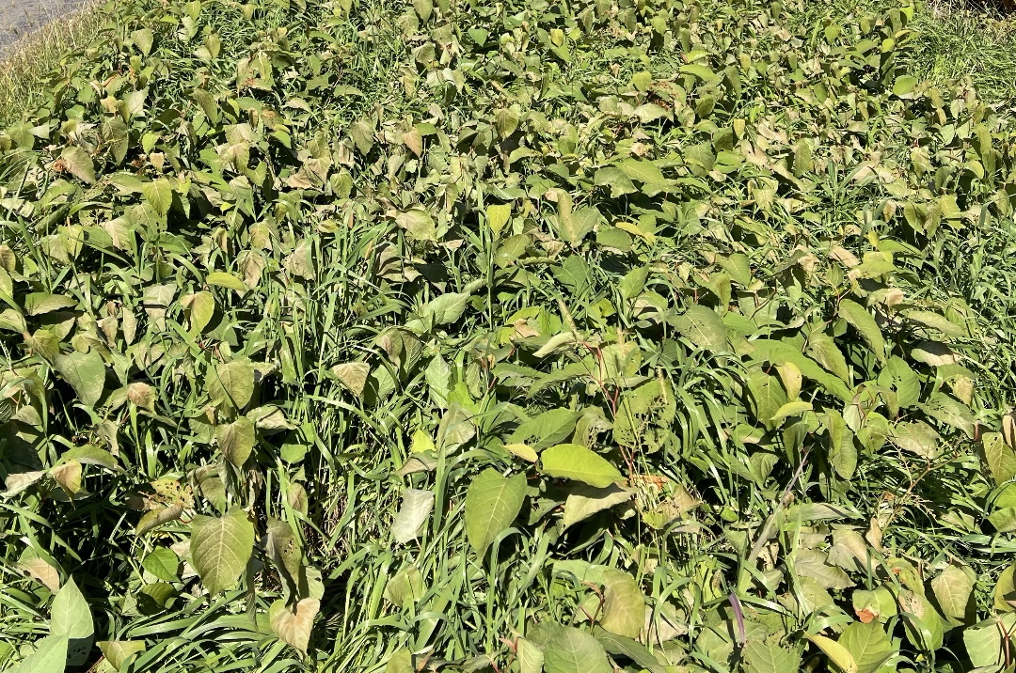

2023 Wisconsin Weed Science Research Report
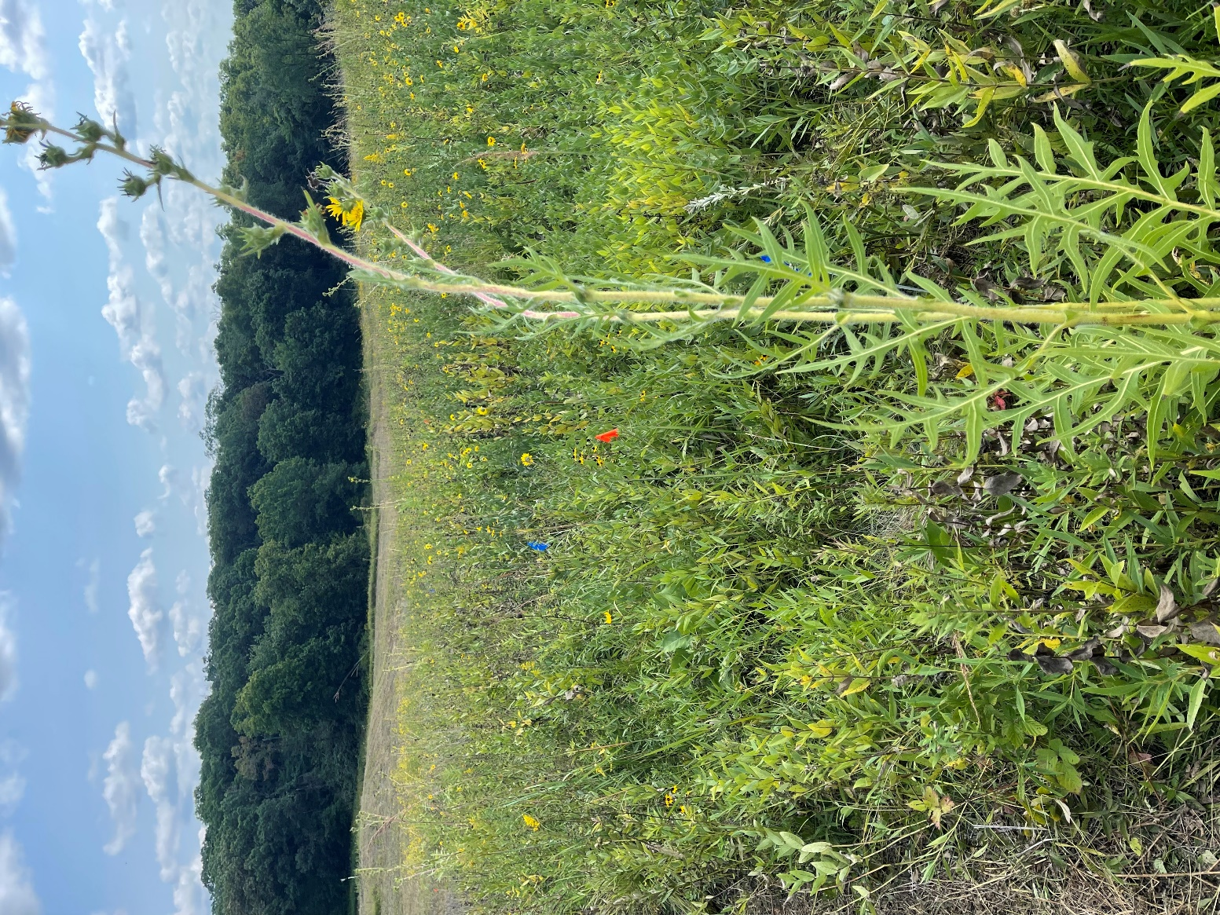
Mark Renz and Travis Wilson
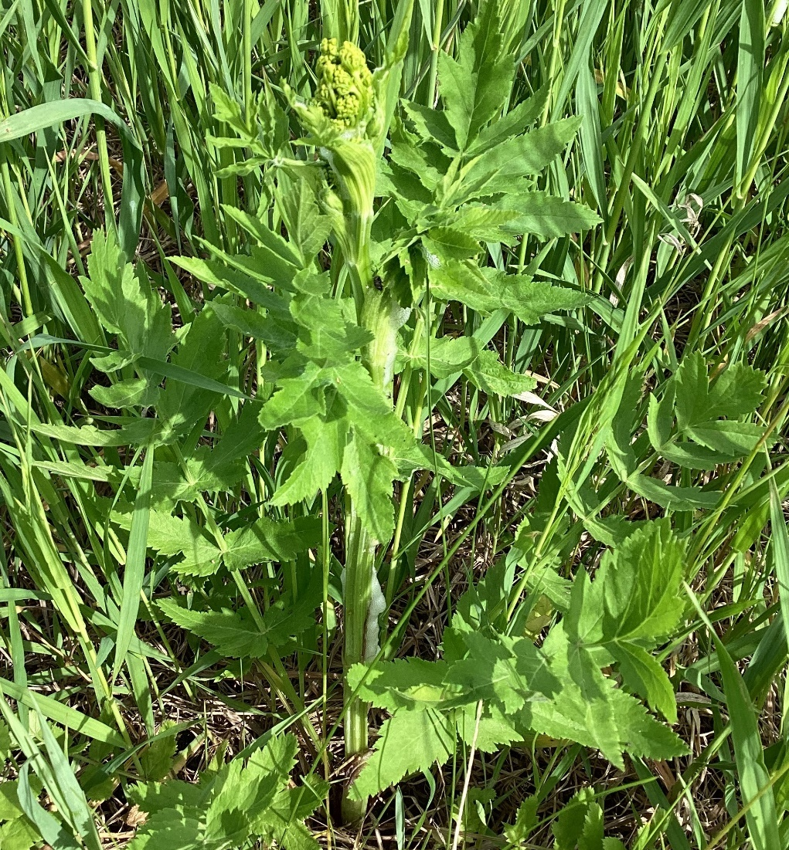

2023 Wisconsin Weed Science Research Team

Dr. Mark Renz
Professor, Extension Weed Specialist

Travis Wilson
Weed Science Research Specialist

Matt Walwrath
Invasive Plants Outreach Coordinator

Weed Science Research Assistants:
Tess Gillingham, Stefania Cartoni Casamitjana, Arthur Franco Teodoro Duarte, Collin Cheney, and Charlton Rodriguez

Please find below a summary of our herbicide trials conducted in 2023. As usual we covered a variety of topical areas and habitats. In 2023 we focused much of our work in native, forb rich prairies where we evaluated the potential for a new herbicide (SiteVue, active ingredient florpyrauxifen) to provide control of invasive plants, specifically wild parsnip. This research builds on other efforts with wild parsnip in New Richmond. We also initiated experiments looking at the impact to native forbs from this product and others when broadcasted and applied to invasive shrubs/trees. All of these projects are ongoing so stay tuned for more information in 2024 with respect to these projects.
Other projects involved evaluating the use of plant growth regulators to reduce height of grasses and continuing to measure efficacy and impact from experiments established in prior years. You will find results on bohemian knotweed, box elder, autumn olive, and ashy sunflower. We even evaluated weed control options when establishing trees with residual herbicides.
In this report you will find a summary of these trials. Detailed information can be found on our website (https://renzweedscience.cals.wisc.edu/research/herbicide-trials/ ).
We would like to thank Corteva, Envu, Alligare, and US Fish and Wildlife Service who have generously supported our research program in 2022 through financial and/or material donations.

This research would not have been possible without the support of land managers and organizations who allowed us access to their land to conduct these trials. We specifically would like to thank:
The Nature Conservancy (Hannah Spaul)
Wisconsin Department of Natural Resources
Parks, Forests and Trails: Craig Anderson
Natural Heritage Conservation: Nate Fayram
Dane County Parks (Lars Higdon)
Highland Spring Farms (Kevin Opperman)
Taliesin (Micheal Degen)
Arlington Ag Research Station (Mike Bertram)
USDA Dairy Forage Research Station (Alison Duff)
Prairie Rose Conservancy (John Barnes)
Bill Johnson
City of Fitchburg (Anna Healy)
City of Rutland (Deana Zentner)
Mississippi Valley Conservancy (Levi Plath)
US Fish and Wildlife Service (Chris Trosen and Tracy Ronnander)
Wild Rivers Conservancy (Alex Bouthilet)
Table of Content
s
Autumn Olive control with florpyrauxifen 6
Forb tolerance to ProClova Herbicide (GF-3731) 7
Does florpyrauxifen control wild parsnip in native prairies? 9
Does florpyrauxifen control wild parsnip in native prairies when coupled with controlled burning? 10
Effectiveness of fall applications of florpyrauxifen on wild parsnip 11
Effectiveness of TerraVue on Box Elder 12
Effectiveness of Herbicides on Ashy Sunflower (Helianthus mollis) 13
Does mowing impact effectiveness of herbicides on Ashy Sunflower (Helianthus mollis)? 14
Effectiveness of Method 240SL on Bohemian Knotweed (Fallopia x bohemica) 15
Imazapic effectiveness on roadside grass and seedhead suppression when compared to other Plant Growth Regulators 16
Controlling wild parsnip in a native prairie 17
Impact of wild parsnip on native forbs 18
Native Forb Tolerance to Herbicides - Verona 19
Native Forb Tolerance to Herbicides - Barneveld 20
Native Forb Tolerance to Herbicides – Prairie du Sac 21
Forb Tolerance to IPT Management – Arlington 22
Forb Tolerance to IPT Management – Waubesa 23
Impact of herbicide applications to recently planted desirable trees 24
Rate of SiteVue (florpyrauxifen) that will control wild parsnip 25

Autumn Olive control with florpyrauxifen
(Trial # 21-9)
Objective: Evaluate the effectiveness of products that contain florpyrauxifen (TerraVue, DuraCor) alone or mixed with other products in controlling Autumn Olive.

Trial Summary
Initial results found high initial levels of control from treatments. Leaf drop was high (>80%) 28 Days after Treatment (DAT) and similar across treatments. By fall (79 DAT) no green leaves existed with all treatments providing 100% control. While a few trees did show signs of resprouting it was minimal, and the amount did not differ among treatments.
One year after application (373 DAT) all treatments provided acceptable control (>92%) and did not differ (P<0.05). Only GrazonNext + Remedy had no resprouting at this time, but by October (437 DAT) most treatments had no resprouts, with the exception of DuraCor alone or mixed with Remedy (one out of seven trees survived). This suggests that the additional florpyrauxifen in treatments 3 and 5 are increasing mortality but additional research is needed to verify this observation. Two years after treatment trends remained similar. High mortality (>90%) of autumn olive was observed for all treatments except for the treatment with DuraCor + SiteVue + Remedy Ultra, (80% mortality). The only treatment that saw a mortality of 100% was TerraVue + Vastlan.
Results confirm that foliar applications of DuraCor or TerraVue provide high levels of control of autumn olive (>90%) one year after treatment. Addition of triclopyr may be enhancing long-term mortality but further research is required on larger trees to confirm.

For full report please follow this link (21-9).

Forb tolerance to ProClova Herbicide (GF-3731)
(Trial # 21-11)
Objective: Determine if differences in forb tolerance exist with applications of florpyrauxifen (SiteVue) when mixed with 2,4-D (ProClova), aminopyralid (DuraCor) or triclopyr.

Trial Summary
Eight native forb species were present in high enough densities to evaluate impacts from herbicide treatments in the year of application. Some level of injury was observed on all forbs the year of treatment, with <50% of foliage injured within the first month with most species/treatments. Fleabane was sensitive to all treatments with high mortality by summer. Canada goldenrod was sensitive to mixtures of florpyrauxifen mixed with triclopyr with over 60% injury through August. In contrast florpyrauxifen mixed with 2,4-D (ProClova) and aminopyralid (DuraCor) injured bergamot more than other treatments. Other species evaluated showed high (<16%) to moderate (16-50%) tolerance, but results are highly variable.
One year after treatments (13 MAT) only one species (Canada goldenrod) had higher cover compared to the nontreated control (P<0.05). Wild bergamot, aster spp., yarrow, and stiff goldenrod appeared relatively tolerant to all treatments one YAT. Black eyed susans were susceptible to aminopyralid containing products and compass plant to florpyrauxifen. While Canada goldenrod cover was reduced with some treatments it was still abundant in all plots.
Large reductions in all forbs were observed in 2023. This likely was due to the drought experienced in 2023. No differences in forb cover were observed this year. Despite the lack of differences, it appears that several forbs maintain cover at similar levels as the non-treated controls (see graphs below for detailed information). These results suggest that other factors may be a bigger influence in forb cover than one herbicide application two years prior.

For full report please follow this link (21-11).

Protecting human health by controlling invasive woody shrubs in the Kickapoo Valley
(Trial # 21-14)

Objective: Confirm that maintaining woody invasive populations at <10% cover will reduce tick populations and determine distance from high use area required to suppress invasive shrubs to minimize harm from ticks.

Trial Summary
Forest understories dominated by Japanese barberry (Berberis thunbergii) have been shown to support higher abundance of blacklegged ticks (Ixodes scapularis) and higher prevalence of Lyme-infested blacklegged ticks than uninfested areas. Where barberry infestations occur in areas used by people for work or recreation, land managers may be inclined to mitigate people’s exposure to the ticks by managing the barberry. In cases where infestations are too large to manage, land managers need to know to what extent they need to manage the barberry to reduce tick exposure, which includes understanding which barberry management techniques are most effective at both controlling the barberry and reducing tick habitat. We studied four barberry management techniques at two sites in Onalaska and Spring Green, Wisconsin with high (>50%) Japanese barberry cover. In April 2021, we established large plot replicates of the following barberry control treatments: (1) Mechanical removal followed by cut-stump herbicide treatment with glyphosate (Roundup); (2) Mechanical removal followed by flame treatment; (3) Foliar herbicide treatment with metsulfuron methyl (Escort); and (4) Foliar herbicide treatment with glyphosate (Roundup). Temperature and relative humidity sensors were installed in each treatment at both sites to document microclimatic conditions that impact tick survival.
Initial results from the 2021 growing season show that foliar treatments provided greater than 90% barberry control at both sites, while the treatments with mechanical removal provided from 60-80% control. All treated areas had microclimatic conditions less suitable for ticks than areas where the barberry was left unmanaged. In fall 2021 (6 months after treatment) all treatments provided significant control of Japanese barberry. Foliar treatments were the most effective (over 90% barberry control at both sites, while the treatments with mechanical removal were between 60 and 80% control. Similar results were observed one and two years after treatment with foliar remaining the most effective, followed by mechanical followed by herbicide to the cut stump, then mechanical followed by direct flame.
Impacts were observed from treatments, especially in areas of high density like Taliesin. At this location foliar application reduced diversity and cover of desirable plants the year after treatment. This reduction mostly disappeared after two years though. In lower density infestations like Onalaska, impacts were minimal the year after treatment and continued to be minimal.
While all treatments reduced Japanese barberry and environmental conditions conducive to ticks, foliar applications were the most effective approach. However, they had a higher impact on non-target species, especially in high density situations. Newer infestations, with lower densities should be prioritized as risks to desirable plants are minimized with this approach.

For full report please follow this link (21-14).

Does florpyrauxifen control wild parsnip in native prairies?
(Trial # 22-5)
Objective: Determine the effectiveness of florpyrauxifen at controlling wild parsnip (Pastinaca sativa) in an establishing native prairie.

Trial Summary
Wild parsnip, while susceptible to many herbicides, these products often also injure/kill desirable forbs in native prairies. SiteVue (florpyrauxifen) is a new product that many native forbs are tolerant to and is effective at controlling wild parsnip. We sought to understand what rates of florpyrauxifen alone or mixed with other products can control wild parsnip in an establishing prairie. All treatments reduced wild parsnip density compared to nontreated controls (25-100% reduction). Few parsnip plants flowered as a result of treatment with SiteVue at 6 and 8 fl. oz/A alone and SiteVue at 4 fl oz/A mixed with Escort having none, 53 days after treatment (7/19). While many wild parsnip plants were not killed at this time they were not flowering and no plants appeared to produce any viable seeds. As seedlings were present at the time of application we assessed seedling survival in October by counting rosettes. While we found no differences in rosette density 130 DAT (10/4) SiteVue at 8 fl oz/A and SiteVue at 4 fl oz/A + Freelex had no rosettes present. This suggests that these treatments eliminated all seedlings and will have no flowering parsnip the following year. Native forb cover was low in plots (<10% cover) with few species, but appears to have been impacted by treatments 53 DAT.

The following year (376 days after treatment), there were no differences among the treatments for parsnip rosettes when compared to the NTC. Despite this, higher rates of SiteVue (6 and 8 fl oz/a) and mixes of SiteVue 4 fl oz/a + Freelex or Plateau all had 0 rosettes at this time. By July (409 DAT), no differences in flowering parsnip was detected. While the variability was high, treatments that applied SiteVue at 4 fl oz/A alone or in combination with Escort or Freelex had no flowering wild parsnip.
Despite the lack of differences in wild parsnip control, native forbs increased in cover 1 year after treatment as cover improved for all treatments 5 to 10 fold except, SiteVue + Escort 409 DAT. SiteVue 2 fl oz/a, showed similar forb cover as the non-treated control (20-30%), at this time. Results suggest that forbs present had some tolerance to SiteVue and, while injured the year of application, could recover to higher levels by one year after treatment. Future research will need to determine at what level of wild parsnip infestation control is needed to minimize injury to forbs while maximizing control.

For full report please follow this link (22-5).

Does florpyrauxifen control wild parsnip in native prairies when coupled with controlled burning?
(Trial # 22-6)
Objective: Determine the effectiveness of florpyrauxifen at controlling wild parsnip (Pastinaca sativa) in an establishing native prairie that has previously had a spring prescribed fire.
Trial Summary
Wild parsnip, while sensitive to a wide range of herbicides, these products often also injure/kill desirable forbs in native prairies. SiteVue (florpyrauxifen) is a new product that many native forbs are tolerant to and is effective at controlling wild parsnip. We sought to understand what rates of florpyrauxifen alone or mixed with other products can control wild parsnip in an establishing prairie. As spring prescribed burns are common in this system this experiment was conducted in areas that were burned in April to evaluate if herbicides and prescribed fire can give improved control. While not statistically analyzed, burning reduced reproductive wild parsnip density 48% compared to a non-burned area 53 days after treatment (7/19). Similar to non-burned research (2022 USFWS Parsnip Unburned Study), all treatments reduced wild parsnip density compared to nontreated controls (85-98% reduction). Few parsnip plants flowered as a result of treatment with SiteVue at 6 fl oz/A alone and SiteVue at 4 fl oz/A mixed with Escort eliminating parsnip 53 days after treatment (7/19). While many wild parsnip plants were not killed at this time they were not flowering and no plants appeared to produce any viable seeds. As seedlings were present at the time of application we assessed seedling survival in October by counting rosettes. Burning in spring increased the number of surviving rosettes in fall by 46%. Prescribed fire can stimulate germination of seed, and apparently was the case at this site. Unlike the not burned study rosette density 130 DAT (10/4) was decreased by all treatments with SiteVue at 4 fl oz/A alone and mixed with Escort not having any fall rosettes. Native forb cover was low in plots (<10% cover) with few species, but may have been impacted by treatments 53 DAT.

One year after treatment (376 DAT), rosette counts were similar among treatments with SiteVue at 4 fl oz/a having no parsnip rosettes. By summer (409 DAT) few flowering parsnips were present (< 3 per plot) and didn’t differ among treatments. Despite the lack of difference, SiteVue at 4 fl oz/a and SiteVue at 4 fl oz/a + Freelex had no flowering parsnip. Native forb cover improved over the course of the experiment (6-22% 409 DAT), with treatments having no significant difference from non-treated areas.

Florpyrauxifen effectively controlled wild parsnip when applied alone or mixed with other herbicides. Treatments provided two years of effective control with few plants producing viable seed in the second year. While impacts to native forbs was observed they did not persist past the treated year. Results suggest that applications could be utilized in a densely infested prairie system to reduce the impact of parsnip and allow for native forbs to establish.

For full report please follow this link (22-6).

Effectiveness of fall applications of florpyrauxifen on wild parsnip
(Trial # 22-7)

Objective: Determine the effectiveness of florpyrauxifen (SiteVue) in controlling wild parsnip in an establishing prairie when applied in the fall.
Trial Summary
Wild parsnip is a problematic invasive plant in Wisconsin. It has been observed infesting native, forb rich, prairies where limited tools for management are available that do not also injure native forbs. A new product, florpyrauxifen (SiteVue), has shown promise in controlling wild parsnip while not harming native forbs, but field trials need to confirm this observation. This experiment is evaluating the effectiveness of florpyrauxifen from fall applications. This project is similar to other projects evaluating spring effectiveness of florpyrauxifen in areas previously burned (22-6) and not burned (22-5). Results from June (246 DAT) showed that all treatments reduced wild parsnip to low numbers (< 3 per plot) and July (279 DAT) showed that all treatments reduced flowering parsnip to low numbers (< 1 per plot). This suggests that florpyrauxifen alone or mixed with other products is extremely effective at suppressing wild parsnip. While not tested, this research also suggests that fall timing is the most effective time to remove flowering parsnip plants. The only drawback is that seedings that germinate the following spring are not inhibited by any of these treatments.

For full report please follow this link (22-7).

Effectiveness of TerraVue on Box Elder
(Trial # 22-8)
Objective: Evaluate the effectiveness of florpyrauxifen (TerraVue) alone or when mixed with other products in controlling box elder and if adding gibberellic acid can improve control.
Trial Summary
Box elder is a common woody weed in many grassland systems. It can be challenging to control with herbicides as uptake into the woody tissue is minimized by early leaf drop. Including florpyrauxifen with other active ingredients may improve control, and the addition of gibberellic acid could also low leaf drop allowing for more herbicide uptake and improved control. Experiments were established and treated in August of 2023. All treatments with herbicides showed high levels of foliar injury 20 days after treatment (DAT). The gibberellic acid treatment alone had no significant injury (9%) compared to nontreated plants. While differences in control were observed 20 DAT all herbicides provided > 75% control. This early season rating often is not a good indicator of long-term control and followup results will be needed to be taken the following spring to evaluate effectiveness of treatments and if gibberellic acid improved control.
One year after application all herbicide treatments, excluding treatment with only gibberellic acid, showed a high control (>90%) of box elder. All treatments showed no resprouting aside from those with the herbicide mixes: TerraVue+Vastlan+Escort WG and TerraVue +Vastlan+ SiteVue VM. With both treatments having one live tree, with three resprouts each, out of eight trees.

For full report please follow this link (22-8).

Effectiveness of Herbicides on Ashy Sunflower (Helianthus mollis)
(Trial # 22-9)

Objective: Determine effectiveness of the herbicide Method 240SL, compared to others, on non-native ashy sunflower (Helianthus mollis) invading a native, forb-rich prairie.
Trial Summary
Ashy sunflower (Helianthus mollis) is a newly discovered species invading forb rich native prairie plantings. While native in some Midwestern states, it is not native to Wisconsin and has been observed to establish and dominate prairies, displacing native forbs and even native grasses like little bluestem. While the distribution of this plant is not well known in Wisconsin, a native prairie in southern Wisconsin is widely overrun by this non-native plant. Therefore, we established a herbicide trial to determine if fall applications of systemic herbicides safe to established grasses will provide suppression of this species and if so increase the cover of native grasses and forbs. Applications were applied in the fall (September) and 30 days after treatment injury was observed. Method (aminocyclopyrachlor) injured ashy sunflower more than Milestone (aminopyralid) and Transline (clopyralid) at this timeframe. The following summer (258 DAT) treatments that included Method or Transline, showed high control (>90%) of ashy sunflower, superior to Milestone (52% control). One year after treatment (358 days) Method was the only herbicide that maintained good control (85% or higher control) with Transline (60%) and Milestone (40%) both having reduced control. Native forb cover responded differentially to treatments. The spring after treatment (258 DAT) Milestone (8%) and Transline (12%), while lower than non-treated plots (17%) had the highest cover of herbicide treatments with Method reducing forb cover (<6%). One year after treatment (358 DAT) Transline had a higher cover of native forbs (28%) than the non-treated control (12%) with only the low rate of Method providing similar cover (18%). These results highlight the impact of ashy sunflower on native forb cover. While Method was the most effective herbicide in suppressing ashy sunflower, it also injured native forbs, therefore should only be applied as an individual plant treatment to avoid injury. If broadcasting, Transline @ 0.67 pt/a is the best option to maintain high forb cover despite modest suppression of ashy sunflower. While individual forb response was not evaluated and likely specific forbs were impacted by herbicide treatment, this experiment demonstrates the benefits of ashy sunflower suppression on native forb cover if the correct herbicide is selected.
For full report please follow this link (22-9).

Does mowing impact effectiveness of herbicides on Ashy Sunflower (Helianthus mollis)?
(Trial # 22-10)

Objective: Determine if mowing a native, forb-rich prairie that is being invaded by non-native ashy sunflower (Helianthus mollis) prior to herbicide application will affect control of species.
Trial Summary
Ashy sunflower (Helianthus mollis) is a newly discovered species invading forb rich native prairie plantings. While native in some Midwestern states, it is not native to Wisconsin and has been observed to establish and dominate prairies, displacing native forbs and even native grasses like little bluestem. While the distribution of this plant is not well known in Wisconsin, a native prairie in southern Wisconsin is widely overrun by this non-native plant. Research is evaluating if fall applications of systemic herbicides that will not harm grasses will provide suppression of this species and if so increase the cover of native grasses and forbs (Effectiveness of Herbicides on Ashy Sunflower (Helianthus mollis). As the landowner mowed areas prior to our application we established an additional experiment that evaluated the impact of herbicides following a recent mowing. No plants regrew following application so no evaluation was taken the year of application. The following summer (258 DAT) we observed control of ashy sunflower from all herbicide treatments (>56%) when compared to the nontreated control. Treatments with Method @ 16 fl oz/a and Milestone @ 5 fl oz/a provided control over 90%. By fall (one year after application) only the treatments with Method @ 12 fl oz/a and Method @ 16 fl oz/a showed good control (>80%). Transline at 0.67 pt/a showed a higher percent of native forb cover than the nontreated control 358 days after treatment. Results were highly variable in this study. This may be due to the differential initial ashy sunflower density and/or different amount of resprouting that occurred after mowing. Even though more variable, results provide evidence that applications after mowing will provide some suppression of ashy sunflower. While not directly tested mowing prior to application may provide additional safety to forbs. This approach requires additional research.
For full report please follow this link (22-10).

Effectiveness of Method 240SL on Bohemian Knotweed (Fallopia x bohemica)
(22-11)

Objective: Determine effectiveness of the herbicide Method 240SL, compared to others, on Bohemian Knotweed (Fallopia x bohemica).

Trial Summary
Bohemian knotweed (Fallopia x bohemica) is widespread throughout Wisconsin and difficult to control. Past research has shown high rates of Milestone (aminopyralid) applied in the fall can give equivalent control as applications of Arsenal (imazapyr). The benefit of Milestone is that established grasses are not harmed. Additionally, interest exists in comparing the effectiveness of Milestone fall applications to Method (aminocyclopyrachlor) and TerraVue (aminopyralid + florpyrauxifen) as these products are also safe to established grasses. Experiments were established in fall 2022 along a highly infested roadside that had been previously mowed to compare these treatments.
Results in spring of 2023 show reductions in knotweed cover for all treatments compared to the nontreated control. Cover of knotweed in July (301 DAT) was lowest with either TerraVue rate or Milestone @ 2.8 5.7 oz/a (cover <15%). While higher rates of Method (16 and 18 fl oz/A) showed promise for control with similar stem counts as Milestone and TerraVue treatments in May (236 DAT), by fall (385 DAT) Milestone and TerraVue treatments only had the fewest stems (<21 stems/m²).
Results highlight that products that contain aminopyralid are the most effective at suppressing bohemian knotweed without injuring grasses. While populations were suppressed, they were not eliminated and had substantial regrowth. This has not been observed in other studies and may have been due to the late application timing after a light frost. This could have limited translocation of herbicides and reduced control.

For full report please follow this link (22-11).

Imazapic effectiveness on roadside grass and seedhead suppression when compared to other Plant Growth Regulators
(Trial #23-1)

Objective: Evaluate imazapic alone or mixed with other plant growth regulators for grass height and seedhead suppression.

Trial Summary
Research continues evaluating the benefit of using plant growth regulators to reduce grass height. If effective less mowing is needed, saving money. In 2023 results were heavily impacted by drought conditions, and grass growth was limited in the summer. Initial results (16 DAT) saw most treatments suppressing growth with only treatments with Pac-Low (16 and 48 fl oz/a) showed similar in height for both tall fescue and Kentucky bluegrass. After one month (31 DAT) treatments that with Pac-Low alone (16 and 48 fl oz/a), Pac-low + Panoramic @ 1 fl oz/a, and Pac-low 16 fl oz/a + T-NEX 16 fl oz/a did not show a significant difference in both tall fescue and Kentucky bluegrass heights when compared to the nontreated control. Treatments with Panoramic (0.5 and 1 fl oz/a) and T-NEX 16 fl oz/a also did not show a significant difference in height for Kentucky bluegrass. All other treatments reduced height of both grass species/
During the growing season mowing was done on plots beginning thirty days after treatment when grasses met one of the criteria 1) reached 20 inches in height or 2) had high seedhead production (> 70% of non treated control). Most plots were mowed as a result of our criteria and the drought. The only treatments that didn’t have all replications mowed at least once throughout the course of the trial was T-NEX 44 fl oz/a + Panoramic 2 fl oz/a and T-Nex 44 fl oz/a + Panoramic 1 fl oz/A.
While the drought prevented us from determining benefits after 30 days, results confirm that Pac-Low was not effective at suppressing grasses at the rates applied. Treatments that contained T-Nex or mainline however displayed promise as results were similar to standard treatments (Panoramic at 2 or 3 fl oz/A). Further results should focus on these products applied alone or with reduced rates of panoramic.
For full report please follow this link (23-1)

Controlling wild parsnip in a native prairie
(Trial # 23-2)

Objective: Evaluate the effectiveness of florpyrauxifen-benzyl alone or mixed with imazapic in controlling wild parsnip and measure the impact on desirable native forbs in forb-rich prairies.

Trial Summary

Wild parsnip is an invasive perennial invading and displacing native forbs within Wisconsin prairies. Limited tools for management are available that do not also injure native forbs. A new product, florpyrauxifen (SiteVue), has shown promise in controlling wild parsnip at low rates while not harming native forbs, but field trials need to confirm this observation. Experiments were established in 2023 to evaluate if florpyrauxifen alone or mixed with imazapic would effectively control wild parsnip and how these applications would change native forbs.

Initial results demonstrated that florpyrauxifen was impacting wild parsnip. While both treatments injured wild parsnip only florpyrauxifen mixed with imazapic reduced flowering wild parsnip density (68%) 22 days after treatment (DAT). By August (43 DAT) both treatments reduced wild parsnip density, but only the mixture effectively reduced flowering parsnip (80%). Many flowering plants were heavily injured and likely had reduced seed viability.
Florpyrauxifen was impacting native forbs.
We observed injury to all native forbs, but injury never exceeded 70% in treated areas except for cup plant which exceeded 80%. Cup plant was also heavily injured by insects in all treatments (NTC 50%), therefore this is likely why injury is elevated. The moderate to high injury from herbicides is a concern, but future data collection in 2024 will determine if plants recover and if control of wild parsnip and elimination of the competition offsets the injury observed.

For full report please follow this link (23-2).

Impact of wild parsnip on native forbs
(Trial # 23-3)

Objective: Evaluate the effect of invasive wild parsnips on native forbs in Wisconsin prairies.

Trial Summary

Wild parsnip is an invasive perennial invading and displacing native forb within Wisconsin prairie. However, it is not known at what threshold of wild parsnip begins to impact native forbs, how intensive the impact is and if management can alleviate this impact. We designed an experiment to measure this response by burning a prairie in spring then controlling emerging wild parsnip after the burn with a non-selective herbicide. The herbicide was applied after the wild parsnip emerged but before native forbs had emerged. This approach was successful in controlling wild parsnip within the prairie as density was reduced three-fold and cover two-fold sixty-two days after treatment. Total native forb cover and density was not impacted by control. Density of developmental classes of native forbs (early, middle, or late season) or individuals also did not differ as a result of management. Current efforts are determining if a relationship exists between wild parsnip and native forbs. This experiment will be continued in 2024 to determine the long-term benefits of continued management on native forbs.

For full report please follow this link (23-3).

Native Forb Tolerance to Herbicides - Verona
(Trial # 23-4)

Objective: Determine the tolerance of native forb species to herbicides commonly used in prairie settings.

Trial Summary
Interest exists in using herbicides to control invasive plants in native and prairies with high populations of forbs. A lack of information exists on the tolerance of forbs to common herbicides used. We established a trial in July near Verona Wisconsin to evaluate the impact of several herbicides treatments to native forbs when applied in mid-summer. The region experienced a severe drought in 2023 which delayed application and may have impacted injury observed.
Forty-eight days after application herbicide treatments impacted nearly all forb species compared to the nontreated control. Only showy goldenrod had injury in treated areas similar to nontreated areas (5-40% injury). Most species displayed some tolerance to all of the treatments (< 60 % injury). Leadplant and compass plant were the two exceptions where injury was > 85 and 60% for each species respectively. Rosinweed, ashy sunflower, bushclover and prairie coreopsis all displayed modest tolerance (35-55% injury) while rattlesnake master and stiff goldenrod showing the best tolerance to herbicides (<30% injury). Increased tolerance was observed within several treatments, but the response was specific to the forb species. In general low rates of Milestone (5 fl oz/A) and Transline treatments had less injury the season of application.
While initial injury suggest some level of forb tolerance from these herbicides, future data collection in 2024 will be needed to confirm safety. Changes in cover and stem density of these species will be compared one year after treatment to better quantify crop safety.

For full report please follow this link (23-4).

Native Forb Tolerance to Herbicides - Barneveld
(Trial # 23-5)

Objective: Determine the tolerance of native forb species to herbicides commonly used in prairie settings.

Trial Summary
Interest exists in using herbicides to control invasive plants in native prairies with high populations of forbs. A lack of information exists on the tolerance of forbs to common herbicides used. We established a trial in July near Barneveld Wisconsin to evaluate the impact of several herbicides treatments to native forbs when applied in mid-summer. The region experienced a severe drought in 2023 which delayed application and may have impacted injury observed.
Thirty-three days after application herbicide treatments impacted all forb species compared to the nontreated control. Despite the injury, all species rates showed moderate tolerance to all of the treatments. False sunflower was injured the most (42-50%), followed by common milkweed (27-37%) with no differences among treatments. Stiff goldenrod displayed similar injury (35-41%) among all treatments except Milestone and the low rate of TerraVue which was less (24-31%).
While initial injury suggest some level of forb tolerance from these herbicides, future data collection in 2024 will be needed to confirm safety. Changes in cover and stem density of these species will be compared one year after treatment to better quantify crop safety.

For full report please follow this link (23-5).

Native Forb Tolerance to Herbicides – Prairie du Sac
(Trial # 23-6)
Objective: Determine the tolerance of native forb species to herbicides commonly used in prairie settings.

Trial Summary
Interest exists in using herbicides to control invasive plants in native and prairies with high populations of forbs. A lack of information exists on the tolerance of forbs to common herbicides used. We established a trial in July near Prairie du Sac, Wisconsin to evaluate the impact of several herbicides treatments to native forbs when applied in mid-summer. The region experienced a severe drought in 2023 which delayed application and may have impacted injury observed.
Thirty-four days after application herbicide treatments impacted the forb species but drought and insect injury added variability to the data which only allowed for significant differences compared to the nontreated control with two species. Rosinweed (22-50%) and stiff goldenrod (19-37%) showed moderate tolerance to herbicide treatments, but injury was higher than non-treated controls. Prairie rose (11-70% injury), cup plant (24-67% injury) and Culver’s root (14-45% injury) all had injuries in treated areas similar to nontreated areas but would be classified as moderately tolerant to moderately susceptible to these herbicides. Rosinweed may be more tolerant to Transline (22% injury) compared to other treatments (35-50% injury).
While initial injury suggest some level of forb tolerance from these herbicides, future data collection in 2024 will be needed to confirm safety. Changes in cover and stem density of these species will be compared one year after treatment to better quantify crop safety.

For full report please follow this link (23-6).

Forb Tolerance to IPT Management – Arlington
(Trial # 23-7)
Objective: Determine the tolerance of native forb species to herbicides commonly used in prairie settings when treating shrubs with the individual plant treatment method.

Trial Summary
Shrub encroachment into prairies is a major problem. While a range of herbicides and methods are effective at removal little is known on the damage and recovery of forbs after treatment. Experiments were established in summer 2023 to access the injury and recover from foliar vs cut surface applications using common herbicides. Foliar treatments were either Durango+Arsenal (glyphosate + imazapyr) or TerraVue + Vastlan (aminopyralid + florpyrauxifen + triclopyr) and the cut surface treatment was Remedy + Milestone (triclopyr + aminopyralid) and a non-treated control.
Twenty-eight days after application the cut surface application of Remedy + Milestone and foliar application of Durango + Arsenal provided excellent control (97-100 % control), while the foliar treatment of TerraVue and Vastlan was only moderately effective (76% control).
Injuries to grasses and native forbs differed among treatments the year of application. Grass injury was only observed with the foliar treatment that included Arsenal (imazapyr). Shrubs treated with Durango + Arsenal were the only ones to show injury (2.5%), which was low. While no injury to grasses was observed, low grass populations near trees/shrubs may have prevented us from detecting any injury to grasses the year of treatment. Forb injury was not able to be detected as forbs has senesced by the time of 28 DAT rating (September 29, 2023). Early senescence was likely due to drought conditions at the location.

For full report please follow this link (23-7).

Forb Tolerance to IPT Management – Waubesa
(Trial # 23-8)
Objective: Determine the tolerance of native forb species to herbicides commonly used in prairie settings when treating shrubs with the individual plant treatment methods.

Trial Summary
Shrub encroachment into prairies is a major problem. While a range of herbicides and methods are effective at removal little is known on the damage and recovery of forbs after treatment. Experiments were established in summer 2023 to access the injury and recover from foliar vs cut surface applications using common herbicides. Foliar treatments were either Durango+Arsenal (glyphosate + imazapyr) or TerraVue + Vastlan (aminopyralid + florpyrauxifen + triclopyr) and the cut surface treatment was Remedy + Milestone (Triclopyr + aminopyralid). All treatments were compared to a non-treated control.
Forty one days after application the cut surface application of Remedy + Milestone and foliar application of Durango + Arsenal provided excellent control (92-100 % control), while the foliar treatment of TerraVue and Vastlan was only moderately effective (62% control).
Injuries to grasses and native forbs differed among treatments the year of application. Grass injury was only observed with the foliar treatment that included Arsenal (imazapyr). While injury was high underneath the shrub (58%) it was observed within 3 ft of the dripline of each (9%) 41 DAT. No grass injury was observed further than three feet away from the Arsenal treated shrubs. Forb injury was not able to be detected as forbs has senesced by the time of 41 DAT rating (September 28, 2023). Early senescence was likely due to drought conditions at the location.
While initial results look promising, measurements 1 year after treatment are needed to accurately assess control and impact to native forbs.

For full report please follow this link (23-8).

Impact of herbicide applications to recently planted desirable trees
(Trial # 23-10)
Objective: Determine which herbicide provides the best weed control around desirable trees recently planted and if residual herbicides injure establishing trees.

Trial Summary
Weed control remained visible 70 days after application. All treatments displayed similar amounts of herbaceous vegetation control ranging from 64-74%. We expected to see higher control with the treatments containing Oust and Esplanade as they both have significant residual activity and prevent emergences of annual species. The drought likely impacted this result as no rainfall occurred for 28 days after application. Herbicides were left on the surface and likely degraded substantially during this timeframe reducing effectiveness.
Despite the drought and lack of rainfall all plants were displaying injury by 70 days after application. The non treated controls had injury from 5-35% depending on species, highlighting the impact of drought conditions on the new tree saplings. Additionally heavy deer browsing occurred, adding additional injury to these trees. Despite these issues, some species still showed higher injury from herbicide applications than others. Black walnut was injured 35% with Oust+Roundup, 13-18% when Roundup alone or mixed with Esplanade was used, which were both higher than the non treated trees. Black cherry appeared to be more sensitive to the Esplanade as the 7 fl oz/a treatment was injured the most (46%) while other treatments were similar to the non treated control (12-23%). Both quaking aspen and hackberry saw no differences among treatments when compared to the nontreated control.
While the drought and deer browsing severely impacted results, this information suggests that injury from high rates of Esplanade and Oust can injure tree species planted that spring, but the response is species specific. Glyphosate alone or mixed with low rates of Esplanade can reduce but not eliminate potential injury.

For full report please follow this link (23-10).

Rate of SiteVue (florpyrauxifen) that will control wild parsnip
(Trial # 23-11)
Objective: Evaluate the effectiveness of florpyrauxifen-benzyl in controlling wild parsnip and if reduced rates can prevent flowering and seed production.

Trial Summary
Wild parsnip is an invasive perennial invading and displacing native forbs within Wisconsin prairies. Its seed can also stay dormant for up to 4 years making it hard to remove from prairies without harming native species. Florpyrauxifen (SiteVue) is a new product that has shown promise in controlling wild parsnip. Experiments were established in 2023 to test what rates of florpyrauxifen would effectively control wild parsnip flowering and seed production compared to standard treatments.
Initial results demonstrated that florpyrauxifen was impacting wild parsnip. Rates as low as 2 fl oz/a of SiteVue reduced flowering and total parsnip 60 days after treatment (DAT). Higher rates (4 fl oz/a) were required to minimize wild non-flowering parsnip. Seed production appears to be reduced at these low rates as by September (138 DAT) 2 fl oz/a minimized the production of inflorescences.
Results suggest that low rates of SiteVue are effective at controlling wild parsnip and preventing seed production. This information will be used to evaluate if these rates will impact native forbs. If safe, this would provide an effective way to control wild parsnip in forb rich prairies.
For full report please follow this link (23-11).

